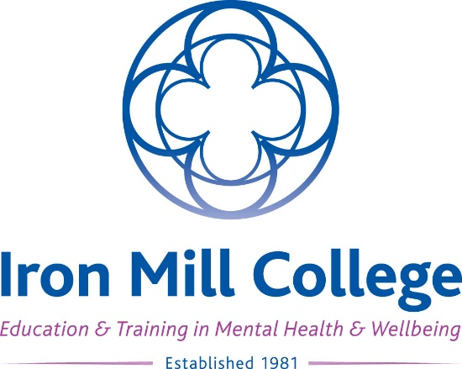

Entry Level Courses Application Form

Many thanks for your interest in Iron Mill College and our courses! This application form is for the Certificate in Counselling and TA Psychotherapy Foundation Course, only. You can also complete your application online on the relevant course web page at www.ironmill.co.uk.

If you need support filling in your form, please contact Amanda Murrell (amanda.murrell@ironmill.co.uk), Learning Support Officer, who will be happy to help.

Your details

First name:
Surname:
Preferred name: (if different from above)
Full postal address: (including post code)
Email address:
Preferred phone number:

Entry level course you are applying for (please specify)

Please tick: (as appropriate) | Name of entry level course: | My venue / day of choice: (delete as applicable) | Start date:
 | Certificate in Counselling | Exeter / Poole  Weekend / Weekday
 | TA Psychotherapy Foundation Course | Exeter  Weekend

I confirm that I have read and agree to the Terms and Conditions of the Student Agreement and the Finance Agreement available on the Iron Mill College web site at www.ironmill.co.uk/student-services/student-agreements.

Signed: Date:

Personal statement

Please tell us about yourself and why you are applying for this course, with reference to your experience in helping and supporting others: (approximately 300 words)
(please continue on additional sheets if necessary)

Disability, mental health, health and learning support

If you have an ongoing health condition, a mental health diagnosis, a disability or have learning support needs, we recommend that you let us know as early as possible. We will contact you to discuss your requirements in relation to the selected course and discuss the support and facilities available.

Please outline any such support requirements here, and our Learning Support Officer will contact you for further information and discussion:
(please continue on additional sheets if necessary)

Where you heard about us

Please tell us where you first heard about Iron Mill College:
Please tell us where you first heard about this particular course:

Deposit and fees

Please confirm that you have paid the applicable deposit for this course by ticking the appropriate statement below (please note, your application cannot be processed until this payment has been made). Please see relevant course web page at www.ironmill.co.uk for full details of deposit due.

Please tick: (as appropriate)
By PayPal via the Iron Mill College website
By credit / debit card over the phone:
By credit / debit card in person at Iron Mill College:
By electronic bank transfer: (please contact us for bank details)
By cheque posted to Iron Mill College / enclosed with this form:
By cheque in person at Iron Mill College:
In cash in person at Iron Mill College:

Please confirm which payment option you would like to choose, following the payment of the applicable deposit (as above). Please see relevant course web page at www.ironmill.co.uk for full details of payment options and schedules.

Payment Options: Certificate in Counselling and TA Psychotherapy Foundation Course only | Please tick: (as appropriate)
Option 1: Deposit, then full balance of fees paid in advance of the course start
Option 2: Deposit, then balance of fees paid in 2 equal instalments (we will contact you with information about how to set up direct payments from your bank)
Bespoke Payment Plan: Deposit, then balance of fees paid in instalments which I have agreed in advance with the Iron Mill College Finance Manager and paid as direct payments from your bank

Please email your completed application form to admissions@ironmill.co.uk, or post to Iron Mill College, 7 Barnfield Crescent, Exeter, Devon, EX1 1QT.
Thank you for your application. We will be in touch within the next few days to confirm we have safely received your application, and to let you know what happens next. We look forward to seeing you soon!

