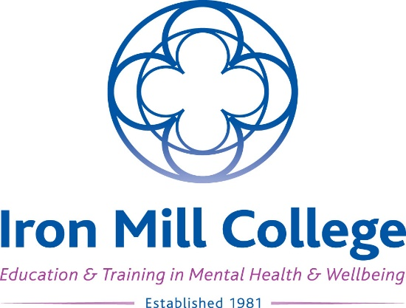

Advanced Courses Application Form

Many thanks for your interest in Iron Mill College and our courses! This application form is for the Advanced Diploma in Integrative Counselling and the TA Psychotherapy Advanced Course only. You can also complete your application online on the relevant course web page at www.ironmill.co.uk.
If you would like to apply for one of our University courses, such as the Foundation Degree (FdA) in Integrative Counselling, please apply via UCAS (at www.ucas.com).

If you need support filling in your form, please contact Amanda Murrell (amanda.murrell@ironmill.co.uk), (Learning Support Officer), who will be happy to help.

Your details

First name:
Surname:
Preferred name: (if different from above)
Full postal address: (including post code)
Email address:
Preferred phone number:

Advanced course you are applying for (please specify)

Please tick: (as appropriate) | Name of Advanced course: | My venue / day of choice: (delete as appropriate) | Start date:
 | Advanced Diploma in Integrative Counselling | Exeter / Poole  Weekend / Weekday
 | TA Psychotherapy Advanced Course | Exeter  Weekend

I confirm that I have read and agree to the Terms and Conditions of the Student Agreement and the Finance Agreement available on the Iron Mill College web site at www.ironmill.co.uk/student-services/student-agreements.

Signed: Date:

Academic qualifications: (most relevant and recent, for which you have a certificate)

Course: (e.g. A Levels, BTEC, Degree, Masters, Doctorate) | College / University: | Start and finish dates: | Result:
(please continue on additional sheets if necessary)

Vocational qualifications: (most relevant and recent, for which you have a certificate)

Course: | Company / College: | Date of completion: | Result:
(please continue on additional sheets if necessary)

References

We will require two references. Your first referee should be a tutor from your preliminary counselling training course. Your tutor should use their college / professional email address when providing your reference. Your second referee must know you well enough to write about you and your suitability for study. The referee should not be a family member, other relative or friend. An employer, health professional or supervisor, can provide references. Please note that it is your responsibility to ensure that your referee is ready to respond promptly to our request for a reference. The college cannot take responsibility for following up reference requests.

Referee 1 name:
Email:
Relationship to you:

Referee 2 name:
Email:
Relationship to you:

Disclosure

Our Advanced Courses require that students work directly and individually with vulnerable people and / or children. In order to ensure we maintain our duty of care towards students and their clients, please indicate:

 | Yes / No: (delete as appropriate)
Have you ever been subject to expulsion from a professional body? | Yes / No
Have you ever been the subject of a disciplinary process with a professional body or in a place of work? | Yes / No
Have you ever been convicted of a criminal offence (including any spent conviction, caution, or bind-over order)? | Yes / No

Answering ‘yes’ to these questions will not necessarily prevent you from successfully gaining a place on the course; however, failure to disclose at this stage, or making a false or an inaccurate declaration, may result in termination of your training. If you have answered ‘yes’ to any of these questions, we will contact you for further details and to discuss your individual situation.

Please tick to confirm:
I would be prepared to undertake an Enhanced DBS check if required for my course, and understand that there is a fee which I would need to pay: (please see the DBS website page for details - www.gov.uk/government/organisations/disclosure-and-barring-service/about)

Course eligibility criteria

Advanced Diploma in Integrative Counselling ONLY | Yes / No: (delete as appropriate)
Have you successfully completed at least a 12 Day Certificate in Counselling which included both theory and practice and has your certificate been achieved within the last 5 years?  (Please note, online only courses do not meet this criteria) | Yes / No
If you have not successfully completed at least a 12 Day Certificate in Counselling - are you able to evidence that your professional training included 12 days of counselling skills training and further evidence relevant work, or study (workshops, online courses, conferences etc.) taken since completion of the training? | Yes / No

TA Psychotherapy Advanced Course ONLY | Yes / No: (delete as appropriate)
Have you successfully completed at least an 18-day TA psychotherapy training course, which included both theory and practice? (Please note, online only courses do not meet this criteria) | Yes / No
Have you successfully completed a 2 day TA 101 workshop? | Yes / No

If you are unsure as to whether you meet the eligibility criteria for your chosen course, please see the relevant course web page for further details (at www.ironmill.co.uk), or contact Ann Dent, Admissions Officer (at admissions@ironmill.co.uk), who will be happy to help you.

Personal statement

Please tell us about yourself and why you are applying for this course, with reference to your previous experience in relevant entry level training: (approximately 300 words)
(please continue on additional sheets if necessary)

Additional requirements

For Advanced courses we will require you to provide additional documents, to give evidence of some of the information you have submitted in this form. Once you have submitted your application, we will write to let you know about any such additional requirements for your chosen course, which you will then need to
bring with you if you are invited to an interview.

Disability, mental health, health and learning support

If you have an ongoing health condition, a mental health diagnosis, a disability or have learning support needs, we recommend that you let us know as early as possible. We will contact you to discuss your requirements in relation to the selected course and discuss the support and facilities available.

Please outline any such support requirements here, and our Learning Support Officer will contact you for further information and discussion:
(please continue on additional sheets if necessary)

Where you heard about us

Please tell us where you first heard about Iron Mill College:
Please tell us where you first heard about this particular course:

Payment Options: Advanced Diploma only | Please tick: (as appropriate)
Early Bird Offer: Deposit, then full course fees paid by either 31st July (Autumn intakes) or 15th March (Spring intakes)
Option 2: Deposit, then one instalment at the beginning of Year 1 and one instalment at the beginning of Year 2 (we will contact you with information about how to set up direct payments from your bank).
Option 3: Deposit, then monthly instalments (we will contact you with information about how to set up direct payments from your bank)

Payment Options: TA courses only | Please tick: (as appropriate)
Option 1: Deposit, then full balance of fees paid in advance of the course start date
Option 2: Deposit, then four instalments (we will contact you with information about how to set up direct payments from your bank)
Bespoke Payment Plan: Deposit, then balance of fees paid in instalments which have been agreed in advance with the Iron Mill College Finance Manager, to be paid as direct payments from your bank (we will contact you with information about how to set up direct payments from your bank)

Please email your completed application form to admissions@ironmill.co.uk, or post to Iron Mill College, 7 Barnfield Crescent, Exeter, Devon, EX1 1QT. Thank you for your application. We will be in touch within the next few days to confirm we have safely received your application, and to let you know what happens next. We look forward to seeing you soon!

